Verbal | Graph
Given the function:  f(x) = x² – 4x | 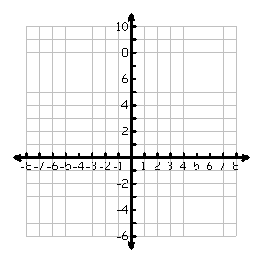
Table | Analysis
 | - Determine the average rate of change (ARoC) of f(x) over the interval [1, 5].  - Draw the secant line AB between the points A (1, f(1)) and B (5, f(5)) on the graph above.  - Determine the slope of f(x) at x = 1.  - Determine the equation of the tangent line of f(x) at x = 1.  - Draw the tangent line of f(x) @ x = 1 on the graph above.  - Determine the equation of the normal line of f(x) @ x = 1.  - At what points, if any, are the tangents to the graph of f(x) horizontal?
  x | f(x)
  -3
  -2
  -1
  0
  1
  2
  3
  4
  5
  6
  7
  8
Communicating and Connecting What We Know About ARoC and IRoC

